Question 1. The master clock is from 10MHz to 40MHz

Question 2. The max frequency for SPI is 40MHz

Question 3. 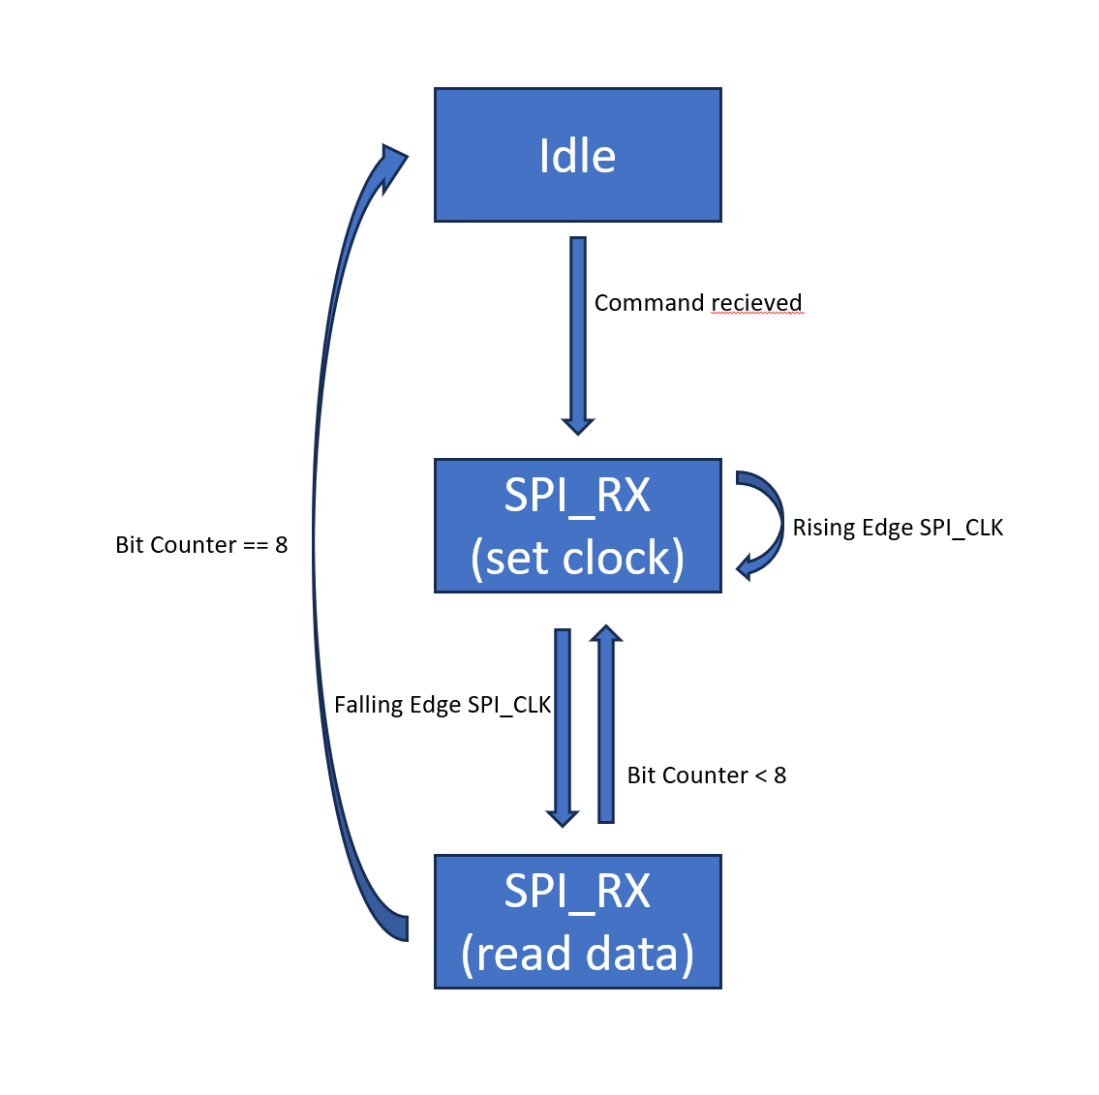This is THE FSM I used for reading data from SPI

Question 4. 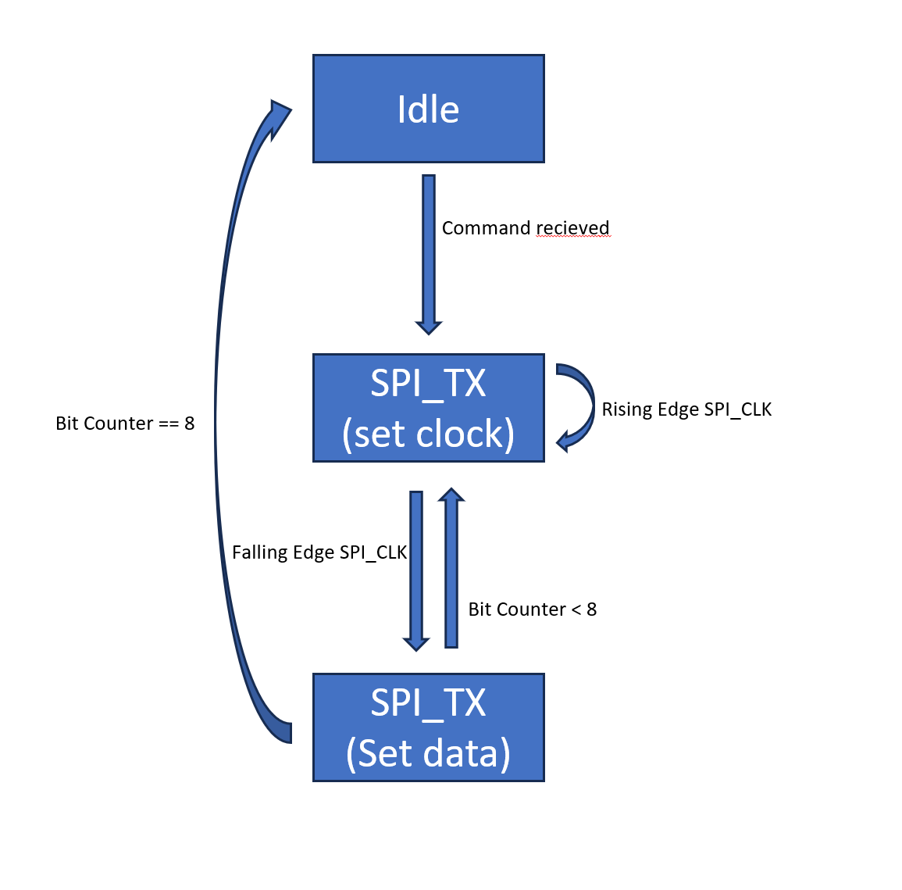This is the FSM I used for writing data from SPI